Viewing an ILP in Skyward

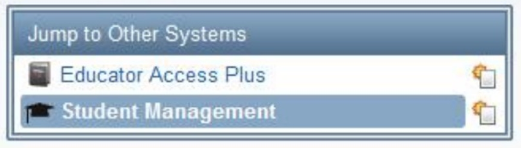
1.) When you go into Skyward, you will need to click on Student Management on the right-hand side under Jump to Other Systems.

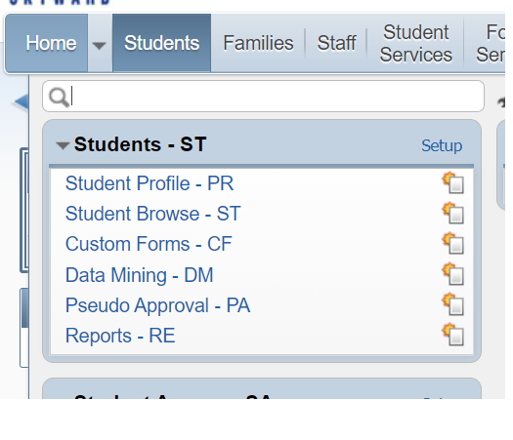
2.) Under Students, click on Student Profile to search for the student.

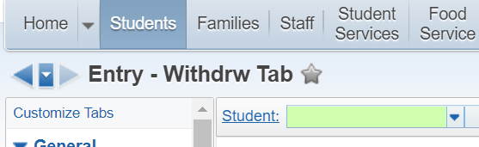
3.) In the search, type the first five letters of the last name followed by the first three letters of the first name.

As you begin typing, options will populate, allowing you to select the student.

4.) To view the ILP, scroll down on the left-hand side until you see Portfolio and click on Attachments. Select the ILP and then click View Attachment.

